# QUANTUM GRID PROJECT

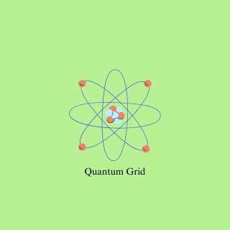

168974 – Koi, JoyJudy Wangui

189545- Omondi, Angela Achieng

189736 – Ikubu, Brian Mathara

192559 – Omenda, Benir Odeny

192083 – Kabese, Gabriel Osugo

193428- Menariya, Suraj Kumar

### SCENARIO:

Kenyan homes and businesses suffer from frequent power outages, delayed token deliveries and even poor customer service from most of the current electricity providers, which significantly impacts our day-to-day lives (e.g. Students being forced to miss virtual classes). Furthermore, some people have little to completely no access to electricity due to the high costs and poor service.

Quantum Grid is a cutting-edge electrical company founded to fix these issues. We provide quick, reliable, affordable and transparent electricity services using contemporary technology. Our goal is to satisfy the needs of the average Kenyan who needs reliable and affordable access to power.

Through our platform, tokens can be provided in less than 30 seconds allowing you to keep track of how much electricity you have used and how it corresponds to how much you will be charged. We also aim to provide great customer service which extends to rural communities that are often left out.

We are dedicated to being transparent with our users by communicating with clarity and forewarning any issues which may occur with our system and where they may occur, thereby allowing you to plan around them and ensuring nobody is ever left in the dark.

With Quantum Grid, events such as studying by a candlelight or missing a virtual class due to absence of electricity, will be a thing of the past. We believe that electricity should never be a struggle for any of our fellow Kenyans.

#Usikae Gizani.

Thank you.

### FUNCTIONAL REQUIREMENTS:

* Users can create and log into their accounts.
* Users can buy electricity and vie they’re tokens with ease, be it by mobile banking & M-Pesa or visiting they’re nearest QuantumGrid branch.
* Users can view their electricity usage and payment history.
* The system immediately generates and delivers tokens after successful payment.
* Admins can monitor transactions and user accounts.
* Meter data can be synced with the user's account in real-time.

### NON-FUNCTIONAL REQUIREMENTS:

* Token requests should be processed by the system within short time periods.
* Users should be able to access the platform with reliable uptime.
* User data must be encrypted and stored securely.
* Scalability to accommodate user growth
* User-friendliness.
* The system should respond to user queries within a couple of hours.

### UML DIAGRAM

